Name: | Destua, Renz Raphael S. | Date: | 08/22/26
Program: | CpE | Section: | B3

A. Learning Outcomes:
At the end of this laboratory, students should be able to:
- Identify software development tools and standards used in software projects.
- Create and manage a GitHub repository.
- Apply Git version control commands.
- Collaborate using GitHub features.
- Demonstrate proper documentation and coding standards.

B. Laboratory Scenario:
You have been hired as a junior software developer in a software company. Your team uses GitHub for source code management and follows coding standards to maintain software quality. Your task is to create a project repository, manage versions of source code, and document your work according to industry standards.

C. Practical Tasks:
- Software Development Tools and Standards
Create a document named Tools_and_Standards.md containing:
- List at least 5 development tools.
- Describe the purpose of each tool.
- Identify at least three coding standards or best practices used in software development.
(Please include the following: 1. Screenshots of the output)
Screenshot of Output
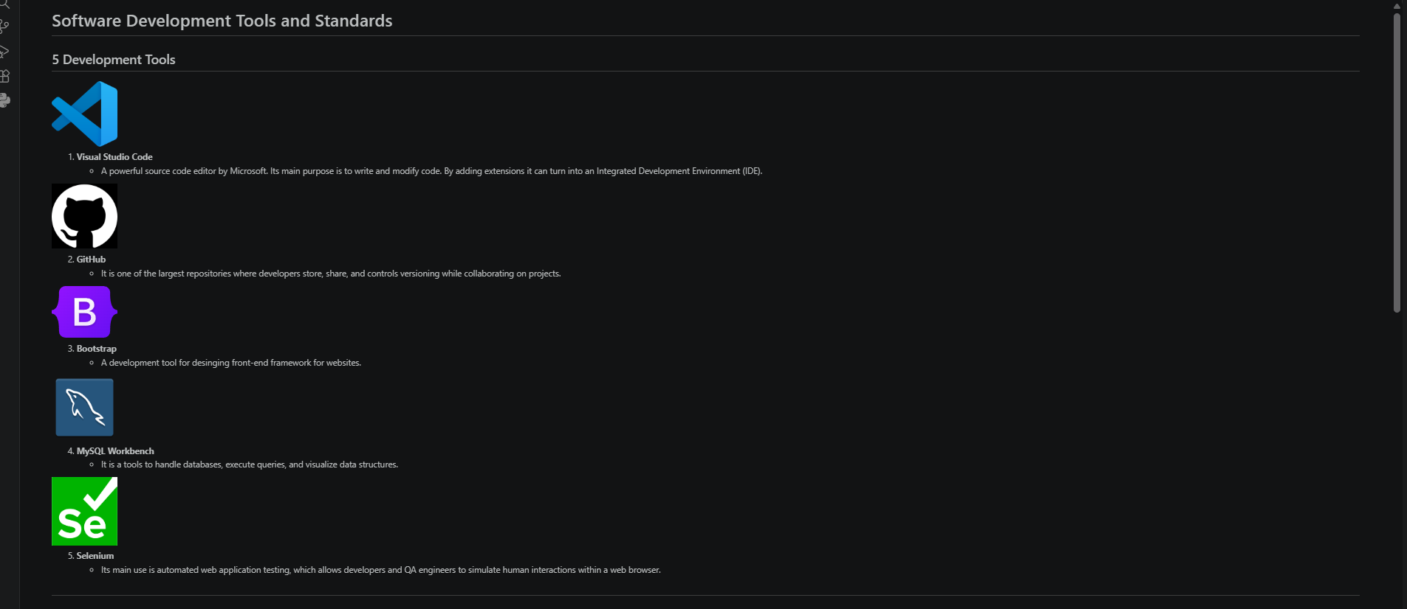

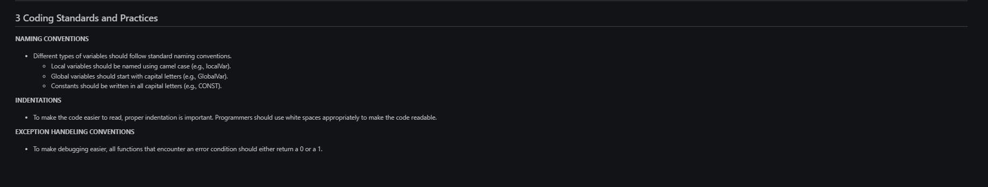
*Resize the image if necessary.

- GitHub Repository Creation
  - Create a GitHub account (if none exists).
  - Create a public repository named: -
  - Add the following:
    - README.md
    - LICENSE
    - .gitignore
  - Upload this laboratory file in this repository once accomplished.
  - Submit GitHub repository link
  - Screenshot of repository homepage

(Please include the following: 1. Screenshots of the output)
Screenshot of Output
(Insert images here from the output)

*Resize the image if necessary.

- Git Version Control
  - Perform the following Git commands and document them in a file named: (Git_Report.md)
    - Clone Repository
      - git clone <repository-url>
    - Creating New Branch
      - git checkout -b feature-update
    - Modify README.md
      - Add your name and laboratory information
    - Commit Changes
      - git add .
      - git commit -m "Updated README with laboratory information"
    - Push Changes
      - git push origin feature-update
    - Create Pull Request
      - feature-update → main
  - Screenshot the following:
    - Commands executed
    - Pull Request
    - Commit history

(Please include the following: 1. Screenshots of the output)
Screenshot of Output
- ii. 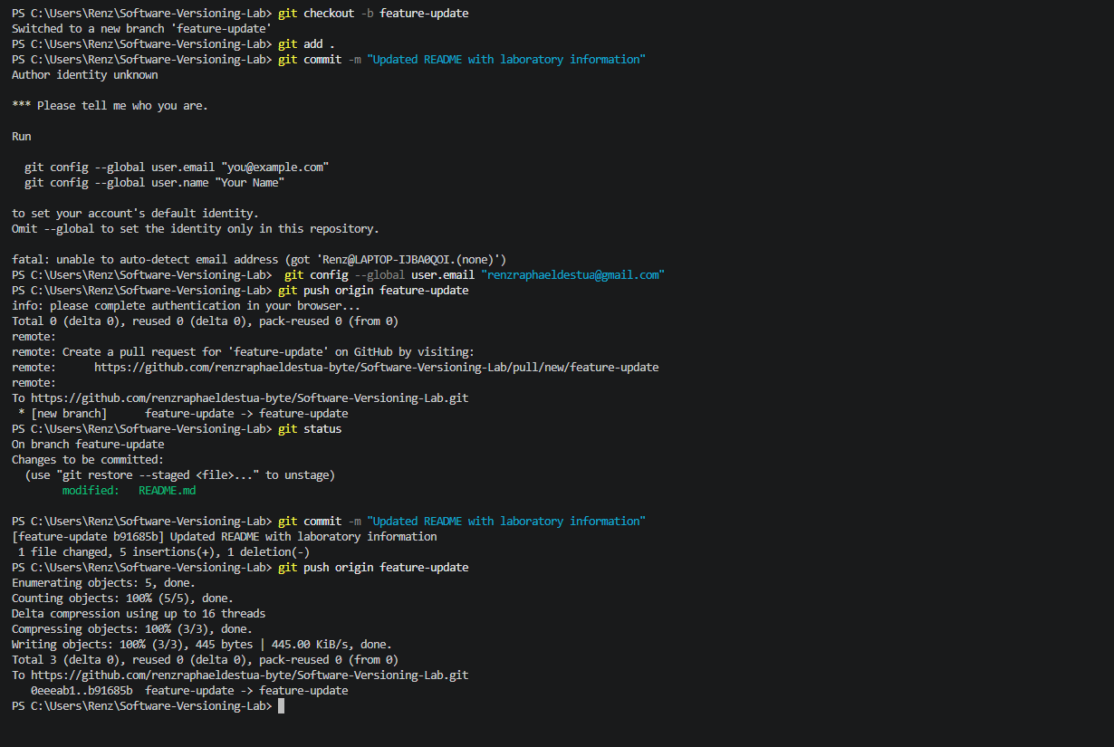

iii.
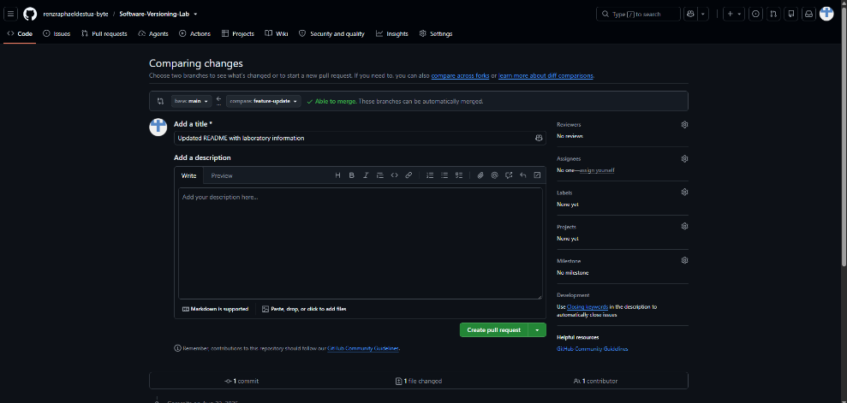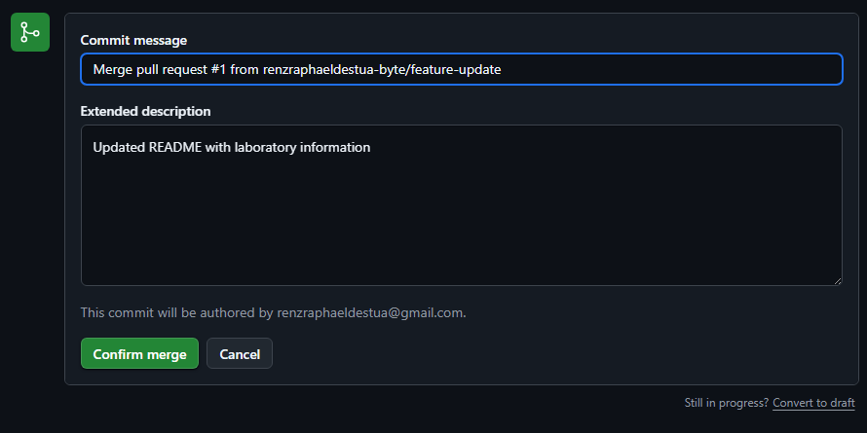

D. Findings, Observations, and Comments:
Guide Questions:
- What additional steps are taken in this activity?
- Are there any difficulties during the GitHub setup?
- What are your findings, observations, and comments in this exercise?

PICTURE/PROOF OF DOING THE ACTIVITY

E. Score Sheet

Criteria | Poor  (25%) | Fair  (50%) | Good  (75%) | Excellent  (100%) | Score
I. Completeness, Documentation, and Organization of Report | The report was incomplete, messy, and had many unanswered questions. | The report was complete, messy, and had many unanswered questions. | The report was complete, neat, and had 1 or 2 unanswered questions. | The report was complete, neat, and all the questions had been answered.
II. Coding Design and Patterns | The program had inappropriate elements and structures, incorrect indention, and poor program documentation. | The program had corrected indention, but inappropriate elements and structures and poor program documentation. | The program had corrected indention, adequate program documentation, but inappropriate elements and structures. | The program had appropriate elements and structures, correct indention, and excellent program documentation.
III. Findings, Observations, and Comments | The findings. observations, and comments were not based on the gathered data and results. All thoughts were inconsistent and unclear. | The findings. observations, and comments based on the gathered data and results but were not elaborated. Not all thoughts were consistent and clear. | The findings. observations, and comments were based on the gathered data and results and were mostly elaborated. Most of the thoughts were consistent and clear. | The findings. observations, and comments were based on the gathered data and results and were completely elaborated. All the thoughts were consistent and clear.
IV. Grammar and Composition | The words used were inappropriate, wrong grammar usage, and poor sentence construction was observed. | The words used were appropriate; however, bad grammar and poor sentence construction were observed. | The words used were appropriate, had proper grammar usage, but poor sentence construction was observed. | The words used were appropriate, had proper grammar usage, and excellent sentence construction.
SCORE:

CHECKED
Rating |  | Signature
 |  | Date

